Braching Strategy:-
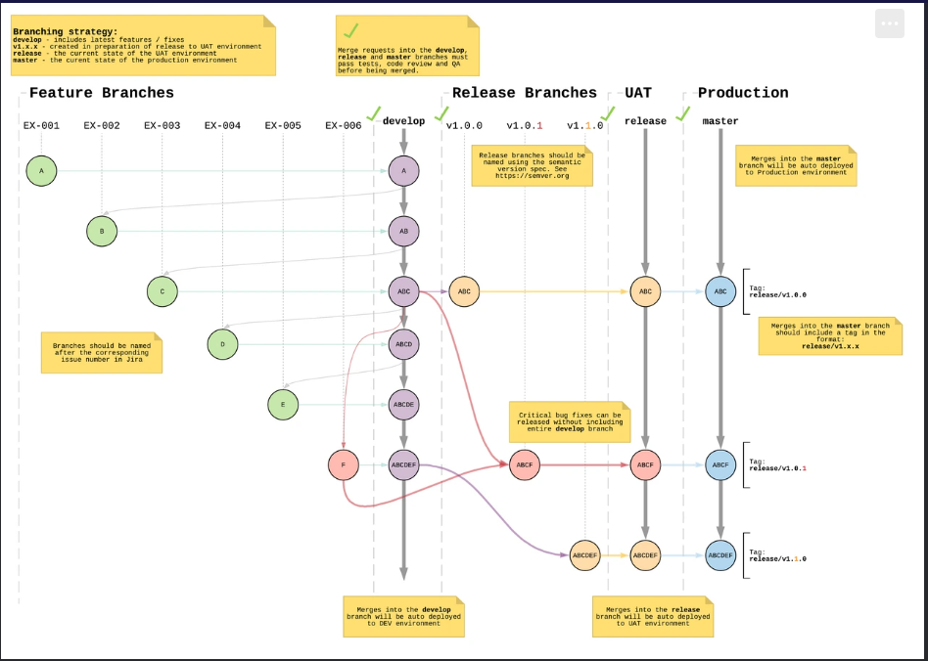

FeatureDevelop branch:-
Every new feature of application continuously created in separated feature branch. Every developers works in their own feature branch.
Here the feature branch naming EX-001, EX-002, EX-003, ….EX-006.
Once the code is ready and reviewed, its merge into develop branch. This keep feature work isolated until its stable.
Each merge triggers auto-deploy to the Dev environment.
Once feature work completed feature branches (A ,B,C) are merged sequentially.
Eg- merge feature branch-A-when Feature branch-A merged into develop branch Jenkins build and deploys the entire develop branch
To the Dev environment.
- Jenkins cicd triggers build new image deploys develop branch to Dev Environment.
merge feature branch-B-when Feature branch-A merged into develop branch Jenkins build and deploys the entire develop branch
To the Dev environment.
Jenkins cicd triggers build new image deploys develop branch to Dev Environment
Same process for every feature branch.

Release Branch:-
Once the develop branch is stable and we’re ready for a release cycle, we create a release branch — for example, release/v1.0.0.
This branch is used for UAT testing. We don’t add new features here; only fix bugs if needed.
It’s like freezing the current stable code for QA to validate.

Eg:-Let’s say we’ve developed 3 features: A, B, and C.
We create a release/v1.0.0 branch from develop and deploy it to UAT for business validation.”

During UAT for version v1.0.0 QA finds critical issue in feature branch-C then we don’t merge the entire develop branch because developers are still working on new features D &E in the develop branch.
If we merge entire Develop branch into release/v1.0.0 we will also bring in D and E – and those are unfinished /untested which can break UAT.

In this scenario we created Bug-Fix branch called F from release branch, after correction done merge it directly to release branch ABCF into release version v1.0.1.

UAT :- Release branch is deployed to the UAT environment.
Here QA and business stakeholders validate end-to-end functionality.
If any bug found its fix directly in the release branch.
Once all validations are done the release branch is approved for production.

Master:-
If everything is ok then
C → ABC (develop) → ABC (release) → ABC (UAT) → ABC (master) → Tag: release/v1.0.0
- Feature C merged to develop →
- develop merged to release →
- release goes to UAT →
- then merged to master →
- and tagged as release/v1.0.0

Above shows successful release.

After correction of Bug fix in release branch.

C → ABC (develop) → ABC (release) → ❌ Bug found in C (UAT)
↓
F (hotfix branch created from release/v1.0.0)
↓
ABCF (release after fix merged)
↓
ABCF (UAT retested & passed)
↓
ABCF (master) → Tag: release/v1.0.1
↓
Merge F → develop (to sync future releases)

